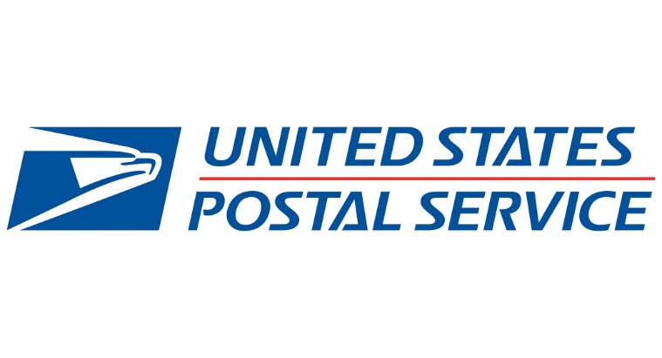 **Job Descriptions & Current Wages**

**PTF City Carrier (In select cities) - $23.53, Career position -** Delivers and collects mail on foot or by vehicle under varying road and weather conditions in a prescribed area; maintains professional and effective public relations with customers and others, requiring a general familiarity with postal laws, regulations, products, and procedures commonly used, and geography of the area. Position typically fastest to be converted to career and works most hours.

**City Carrier Assistant (CCA) - $19.33 – Non-Career.**

**Rural Carrier Associate (RCA) - $20.38 -** Cases, delivers, and collects mail along a prescribed rural route using a vehicle; provides customers on the route with a variety of services. May only work 1-2 days per week. Vehicle may be needed.



**Automotive Technician - Salary $63658 - Career Position. Testing Required** - In this role you will perform both routine and complex repairs and maintenance on all types of motor vehicles in the postal fleet. You will troubleshoot and diagnose more complex vehicle malfunctions and may provide assistance to lower-level employees.

**Mail Handler Assistant (MHA) – $ 19.06/hr. - Non-Career Position**

In this role you will load, unload and move mail and packages. You will also perform other duties incidental to the movement and processing of mail. If you enjoy staying active in a team environment that emphasizes safety and ergonomics this could be a great fit for you.

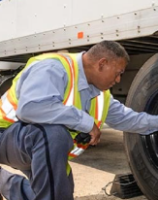**Tractor Trailer Operator (TTO) - $31.96 – Career Position**

**In this role you will regularly operate a heavy-duty tractor-trailer in all weather conditions either in over-the-road, city shuttle service, or trailer spotting operations. Benefits may include health insurance and retirement. This position requires a commercial driver’s license. Many TTO positions offer short delivery runs allowing you more time with your family at home.**

Please scan the QR Code below to provide us your contact information so we can reach out to you and answer any questions you may have or visit usps.com/careers for current positions in your area.

# Saint Paul proudly serves these areas: Apple Valley, Dayton's Bluff, Eagan, Eastern Heights, Elway, Industrial, New Brighton, North St. Paul, Rice St., Riverview, Roseville, Vadnais Heights/Shoreview, White Bear Lake, Woodbury

# Employment Requirements

* 18 years old at the time of appointment or 16 years old with a high school diploma
* United States citizen, permanent resident, or citizen of American Samoa or other U.S. territory
* Recent employment history
* Ability to pass a criminal background check, drug screening, and medical assessment
* 5 YEAR residency within United States or territory of US is needed for background investment.
* Reliable transportation to work
* Safe driving record (if applicable to the position) must have two years of safe, unsupervised documented driving experience in the United States.
* Must be registered with [Selective Service](https://www.sss.gov/default.htm) if male born after December 31, 1959.

# Working at USPS

The United States Postal Service® is the second largest employer in the United States. We offer our team variety, training, and ways to move up. We have specific programs for recent grads and skills matching for applicants with military experience.

From mail carriers to corporate management, we work together to provide efficient, affordable service to the American public. USPS® is an excellent workplace for self-motivated people who enjoy independence and measurable goals with the added satisfaction of serving our communities.

# USPS Benefits

Great benefits include more than good pay. USPS career employees have competitive salaries and premium benefits.

* Multiple health and life insurance choices
* Dental and Vision insurance
* Retirement and thrift savings plans
* Generous vacation time and sick leave
* Qualifying education assistance
* 11 paid holidays per year
* Flexible Spending Accounts
* Long Term care insurance
* Career Development & Training

# Building a Career at USPS

Our workers are the backbone of USPS service. We want to develop and advance careers within USPS, so our development programs train and prepare our employees for promotions and growth in a variety of USPS business areas.

# Benefit Information

**PSE** - **Non-career** 360-day term with possibility of reappointment. May lead to career position.

Benefits include PTO at 1 hr for every 20 hrs in pay status, holiday pay for 6 holidays, and pay raises per APWU National Agreement. Immediately eligible for USPSHB Plan with a $125 employer premium contribution. Contribution towards greater than Self Only is 65% (75% if reappointed). Upon a conditional reappointment to a 2nd 360day term after a break in service of no more than 5 days, eligible for: health insurance under FEHB with Postal premium contributions towards APWU CDHP; dental and vision insurance through FEDVIP; flexible spending accounts through FSAFEDS and long-term care insurance through FLTCIP. Wounded Warrior leave available if eligible.

**CCA** - **Non-career** 360-day term with possibility of reappointment. May lead to career position.

Benefits include paid leave at the rate of 1 hr. for every 20 hrs. in pay status, holiday pay for 6 holidays, and pay raises per NALC National Agreement. Immediately eligible for USPSHB Plan with a $125 Postal premium contribution towards Self Only. Employer contribution towards greater than Self Only is 65% (75% for subsequent appointments). Upon reappointment to a second 360-day term after a 5-day break in service eligible for: health insurance under FEHB; dental and vision insurance through FEDVIP; flexible spending accounts through FSAFEDS and long-term care insurance through FLTCIP. Wounded Warrior leave available if eligibility criteria are met. Effective Plan Year 2022, the Postal Service will make a bi-weekly contribution equal to 75% of the total premium for any CCA employee who wishes to participate in the USPS Plan for self, self plus one, or family coverage, regardless of year of employment.

**RCA** - This is a **non-career** position, which may lead to a career position.

Benefits include paid leave at the rate of 1 hr for every 20 hrs in pay status and pay raises per NALC National Agreement. RCAs are immediately eligible to enroll in the USPS Health Benefits Plan with a Postal Service premium contribution. After completing one year without a break in service of more than 5 days, RCAs may also be eligible for: health insurance under the Federal Employees Health Benefits Program (FEHB); dental and vision insurance through the Federal Employees Dental and Vision Insurance Program (FEDVIP); flexible spending accounts program through FSAFEDS and long-term care insurance through the Federal Long Term Care Insurance Program (FLTCIP). May receive Wounded Warrior leave provided eligibility criteria are met.

**Career Positions** - This is a career position which offers excellent benefits.

Newly hired employees are covered by the Federal Employees Retirement System (FERS). Upon hire, employees are eligible to contribute into the Thrift Savings Plan (TSP) which is similar to 401(k) plans. We also offer the option to enroll into the Federal Employees Health Benefits (FEHB) program as well as the Federal Employees Group Life Insurance (FEGLI). Dental, Vision and Long-Term Care Insurance Programs as well as Flexible Spending Accounts to cover eligible out-of-pocket health care and dependent care (day care) expenses are also available. We offer extra pay when working on a federal holiday (11 per calendar year) as well as accrued vacation and sick leave.